**Abhinav Anand – 22052611 – B16 – C Lab 3   
  
Classwork questions -**1. Print the larger and smaller of the two numbers**.**Answer -   
  
**INPUT -**   
  
//q1)Program to print the larger and smaller of two numbers

#include<stdio.h>

int main(){

int a,b;

printf("Enter the first number: ");

scanf("%d",&a);

printf("Enter the second number: ");

scanf("%d",&b);

if(a>b){

printf("The larger number is %d and smaller number is %d\n",a,b);

}

else{

printf("The larger number is %d and smaller number is %d\n",b,a);

}

}

**OUTPUT -**

Enter the first number: 2

Enter the second number: 3

The larger number is 3 and smaller number is 2.

**Abhinav Anand – 22052611 – B16 – C Lab 3**

2. Print whether the number is even or odd.  
Answer -   
  
**INPUT -**

//q2)Print whether number is even or odd

#include<stdio.h>

int main(){

int a,b;

printf("Enter the number: ");

scanf("%d",&a);

if(a%2==0){

printf("The number is even");

}

else{

printf("The number is odd");

}

}

**OUTPUT -**

Enter the number: 1

The number is odd

**Abhinav Anand – 22052611 – B16 – C Lab 3**

3. Find the largest of three given numbers.  
Answer -   
  
**INPUT -**

//q3)Print larger of three numbers

#include<stdio.h>

int main(){

int a,b,c;

printf("Enter the first number: ");

scanf("%d",&a);

printf("Enter the second number: ");

scanf("%d",&b);

printf("Enter the third number: ");

scanf("%d",&c);

if(a>b && a>c){

printf("Largest Number is: %d\n",a);

}

else if(b>c && b>a){

printf("Largest Number is: %d\n",b);

}

else{

printf("Largest Number is: %d\n",c);

}

}

**OUTPUT -**

Enter the first number: 3

Enter the second number: 4

Enter the third number: 2  
Largest Number is: 4

**Abhinav Anand – 22052611 – B16 – C Lab 3**

4. Check whether a year is a leap or not.Answer -   
  
**INPUT -**

//q4)Find Leap Year or not

#include<stdio.h>

int main(){

int year;

printf("Enter the year: ");

scanf("%d",year);

if(year%4==9 && year%100!=0 || year%400==0){

printf("Leap Year\n");

}

else

printf("Not a Leap Year\n");

}

**OUTPUT -**

Enter the year: 2034

Not a Leap Year

**Abhinav Anand – 22052611 – B16 – C Lab 3**

5. Find the grade of a student based on the marks obtained.  
Answer -   
  
**INPUT -**

//q5)Grade of student

#include<stdio.h>

int main(){

float m1,m2,m3,m4,total,per;

char grade;

printf("Enter the marks of the subjects: ");

scanf("%f""%f""%f""%f",&m1,&m2,&m3,&m4);

total=m1+m2+m3+m4;

per=total/4;

if(per>=85)

grade='A';

else if(per>=70)

grade='B';

else if(per>=55)

grade='C';

else if(per>=40){

grade='D';

}

else

grade='E';

printf("The percentage is %f\n Grade is %c\n",per,grade);

}  
  
  
**OUTPUT -**

Enter the marks of the subjects:

23

4

54

32

The percentage is 28.250000

Grade is E

**Abhinav Anand – 22052611 – B16 – C Lab 3**

**Homework Questions -**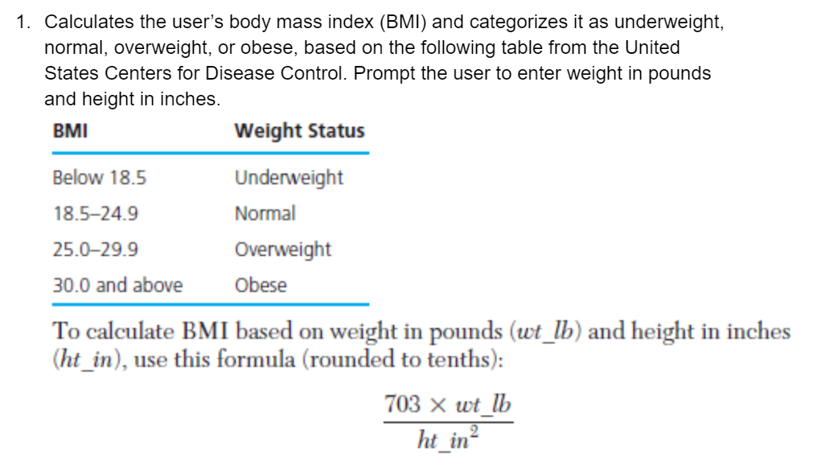Answer -

**INPUT -**

#include<stdio.h>

int main(){

float height,weight,bmi;

printf("Enter the weight in lb: ");

scanf("%f",&weight);

printf("Enter the height in inches: ");

scanf("%f",&height);

bmi=(703*weight)/(height*height);

if(bmi>=30){

printf("Obese");

}

else if(bmi>=25){

printf("Overweight");

}

else if(bmi>=18.5){

printf("Normal");

}

else{

printf("Underweight");

}

}

**OUTPUT -**

Enter the weight in lb: 234

Enter the height in inches: 2

Obese

**Abhinav Anand – 22052611 – B16 – C Lab 3**

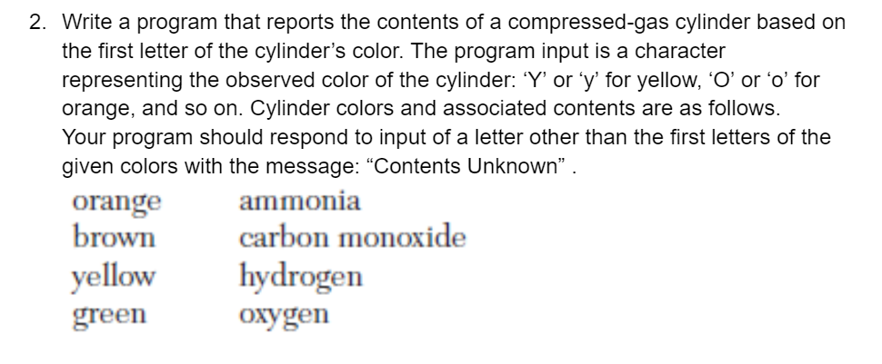  
Answer -   
  
**INPUT -**  
  
#include <stdio.h>

int main()

{

char c;

printf("Enter the colour code:\n");

scanf("%c", &c);

if (c == 'O' || c == 'o')

{

printf("Ammonia");

}

else if (c == 'B' || c == 'b')

{

printf("Carbon Monoxide");

}

else if (c == 'Y' || c == 'y')

{

printf("Hydrogen");

}

else if (c == 'G' || c == 'g')

{

printf("Oxygen");

}

else

{

printf("Contents Unknown");

}

}

**OUTPUT -**

Enter the colour code:

y

Hydrogen

**Abhinav Anand – 22052611 – B16 – C Lab 3**

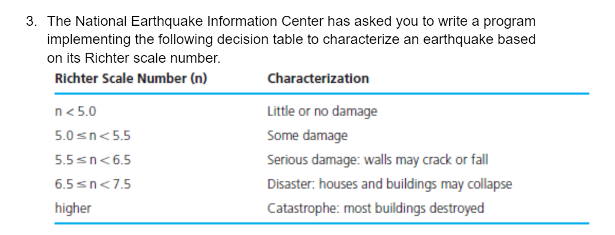

Answer -

**INPUT -**

#include <stdio.h>

int main()

{

float n;

printf("Type the value of earthquake displayed on Ritcher's Scale:\n");

scanf("%f", &n);

if(n<5.0)

{

printf("Little or no damage");

}

else if(n>=5.0&&n<5.5)

{

printf("Some Damage");

}

else if(n>=5.5&&n<6.5)

{

printf("Serious Damage: walls may crack or fall");

}

else if(n>=6.5&&n<7.5)

{

printf("Disaster:house and building may collapse");

}

else

printf("Catastrophe:most building destroyed");

return 0;

}

**OUTPUT -**

Type the value of earthquake displayed on Ritcher's Scale:

6

Serious Damage: walls may crack or fall

**Abhinav Anand – 22052611 – B16 – C Lab 3**

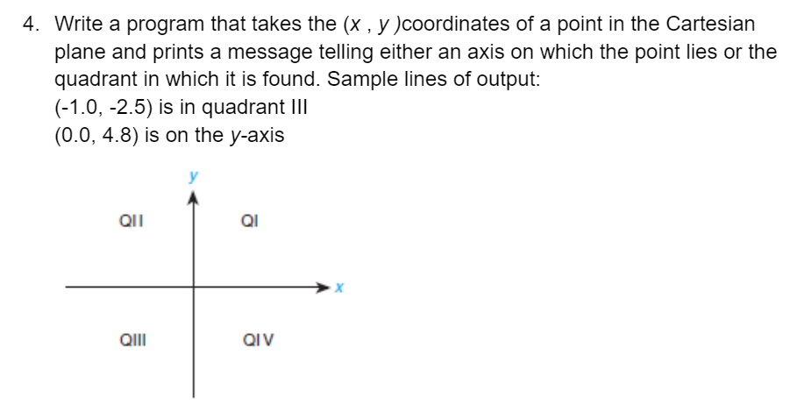

Answer - #include <stdio.h>

**INPUT -**

int main()

{

float x, y;

printf("Enter the x-coordinate: ");

scanf("%f", &x);

printf("Enter the y-coordinate: ");

scanf("%f", &y);

if (x == 0 && y == 0) {

printf("The point is at the origin\n");

} else if (x == 0) {

printf("The point is on the y-axis\n");

} else if (y == 0) {

printf("The point is on the x-axis\n");

} else if (x > 0 && y > 0) {

printf("The point is in quadrant I\n");

} else if (x < 0 && y > 0) {

printf("The point is in quadrant II\n");

} else if (x < 0 && y < 0) {

printf("The point is in quadrant III\n");

} else {

printf("The point is in quadrant IV\n");

}

return 0;

}

**OUTPUT -**

Enter the x-coordinate: 5

Enter the y-coordinate: 6

The point is in quadrant I

**Abhinav Anand – 22052611 – B16 – C Lab 3**

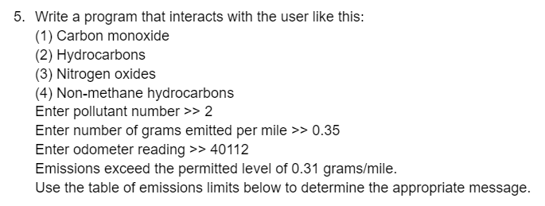

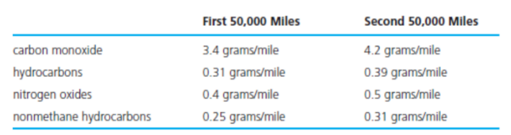  
Answer –

**INPUT -**

#include <stdio.h>

int main()

{

int pollutant;

float gramsPerMile, odometerReading, limit;

printf("(1) Carbon monoxide\n");

printf("(2) Hydrocarbons\n");

printf("(3) Nitrogen oxides\n");

printf("(4) Non-methane hydrocarbons\n");

printf("Enter pollutant number >> ");

scanf("%d", &pollutant);

printf("Enter number of grams emitted per mile >> ");

scanf("%f", &gramsPerMile);

printf("Enter odometer reading >> ");

scanf("%f", &odometerReading);

if (pollutant == 1) {

limit = 3.4;

} else if (pollutant == 2) {

limit = 0.31;

} else if (pollutant == 3) {

limit = 0.4;

} else if (pollutant == 4) {

limit = 0.25;

} else {

printf("Invalid pollutant number\n");

return 1;

}

float emissions = gramsPerMile * odometerReading;

if (emissions > limit) {

printf("Emissions exceed the permitted level of %.2f grams/mile.\n", limit);

} else {

printf("Emissions are within the permitted level of %.2f grams/mile.\n", limit);

}

return 0;

}

**OUTPUT -**

(1) Carbon monoxide

(2) Hydrocarbons

(3) Nitrogen oxides

(4) Non-methane hydrocarbons

Enter pollutant number >> 2

Enter number of grams emitted per mile >> 4

Enter odometer reading >> 3

Emissions exceed the permitted level of 0.31 grams/mile.